Uml diagrams

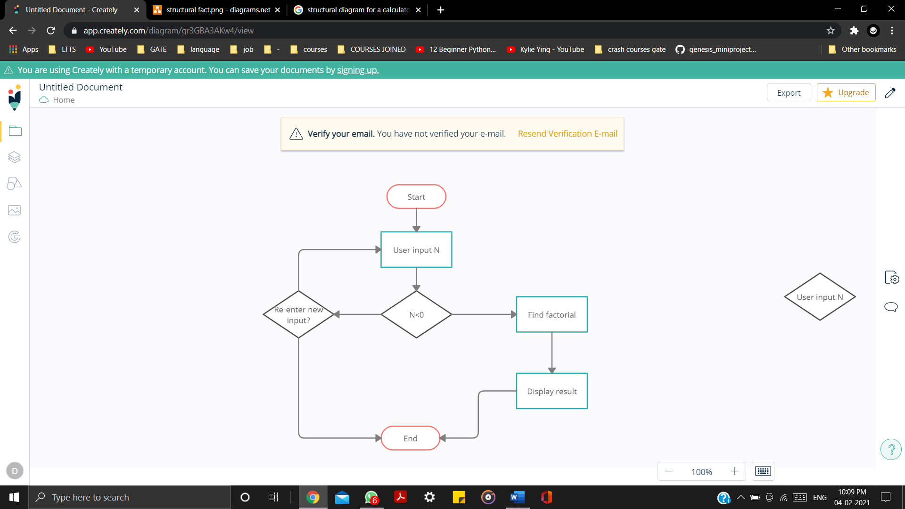
Fig : Behavioral diagram for factorial

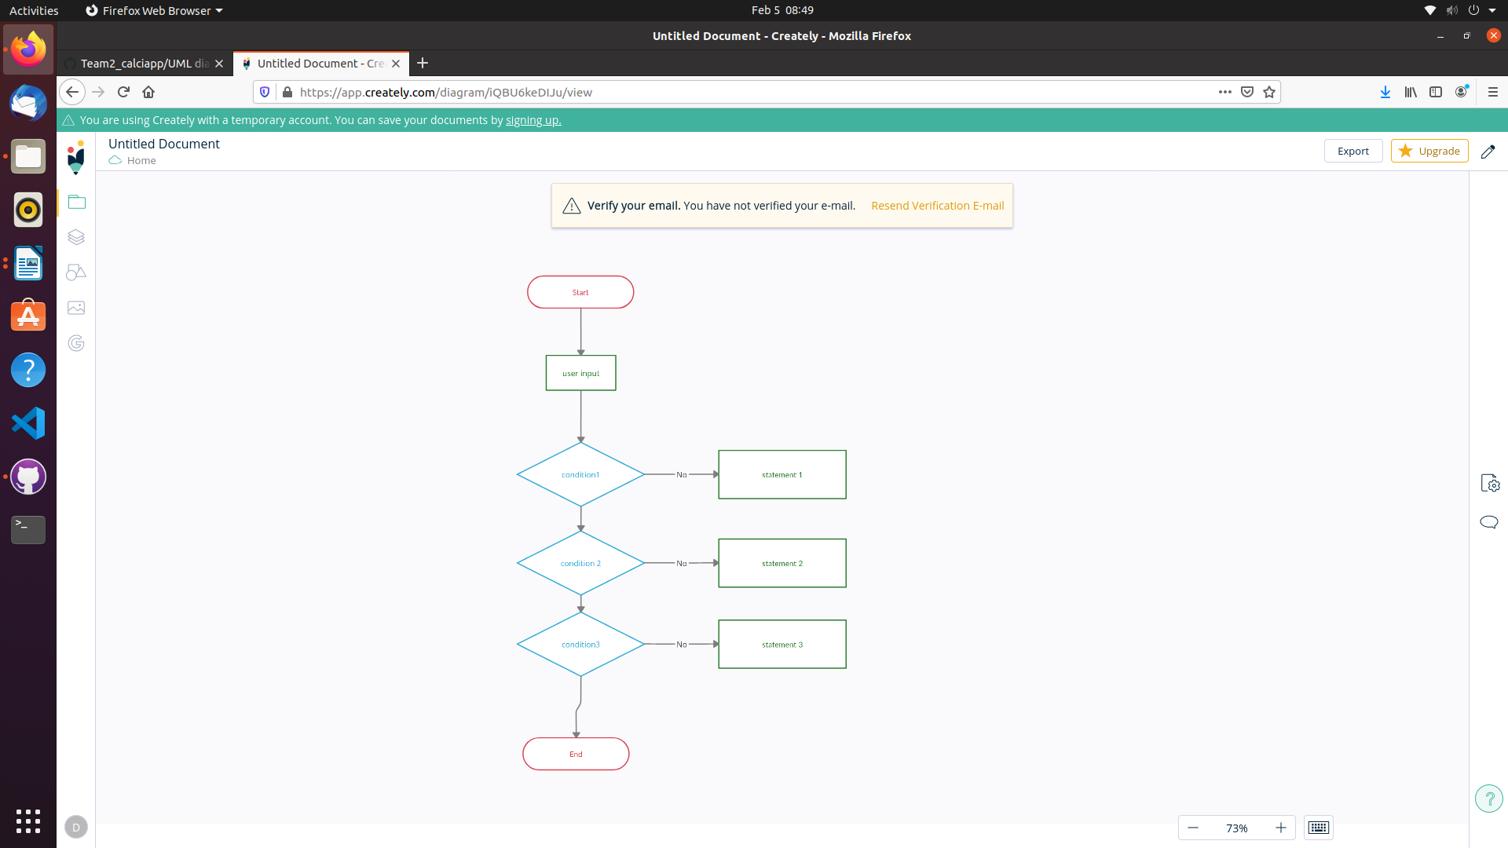

Fig : structural diagram for factorial

